Using the Data visualizer module from DHIS-2 to display indicator data

# Overview:

The DHIS-2 platform has a simple charting module that can be used to display values of Indicators from the DHIS. This has recently been enhanced and is now called Data Visualizer.

There are now 7 chart types available:

1. Line charts for time series data:

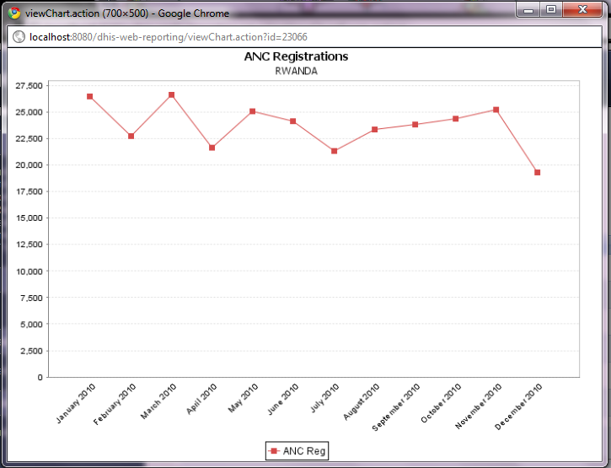

1. Bar charts (usually for categorical data) these can be independent or stacked bars:

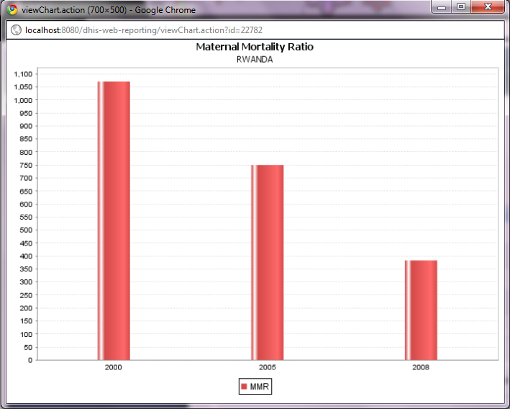

1. Horizontal bar chart:

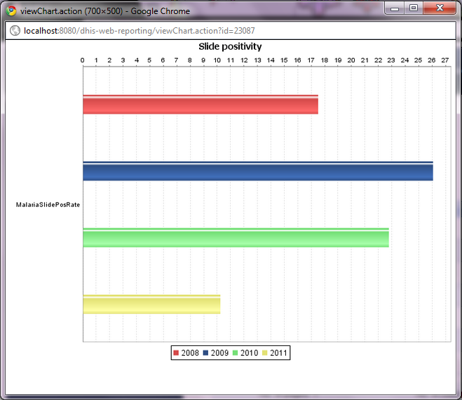

1. OrgUnit chart:

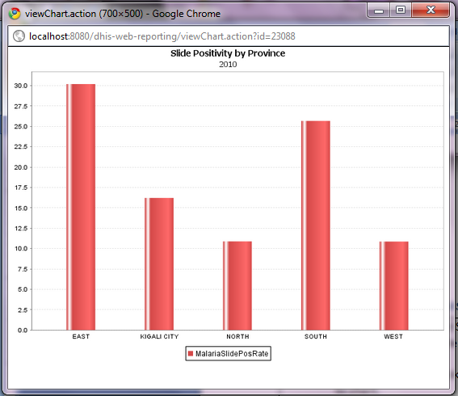

1. Pie chart:

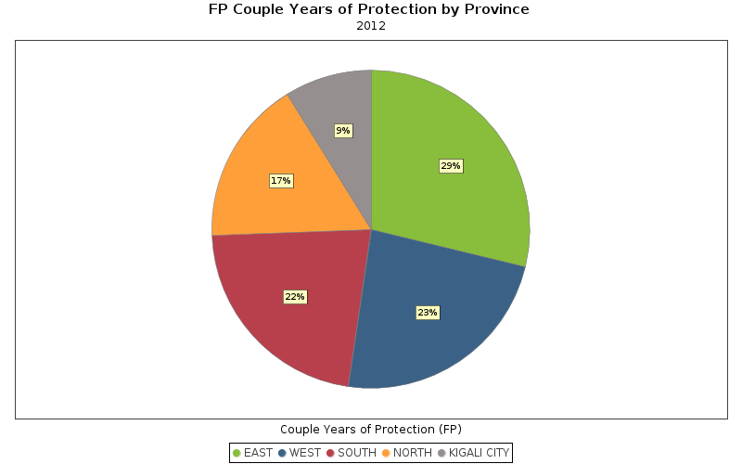

# Step by step guidelines for creating charts:

|  |  |
| --- | --- |
| 1. From the Services menu select Data Visualizer. 2. When you load the Data Visualizer module you see the screen at right. This dialog box enables you to select:    1. Chart type    2. what you want to display in series, categories and filters    3. indicators to display    4. Data elements to display    5. Reporting rates    6. Organization units    7. A list of organization unit groups and thematic areas by which to group the data |  |
|  | |
| 1. For time series analysis, select a line chart or bar chart.    1. Leave the series, Category and Filters with their default (Data, Period and Organisation units)    2. Decide if you want to plot an indicator or data element    3. If you select an indicator, chose the indicator group and then select the indicator |  |
| 1. If you decide to select a data element you will see the screen at right:    1. You can select a data element group using the combo box.    2. Click on the data element(s) you wish to display and move them across to the “Selected” box by clicking on the right arrow icon. You can pick more than one data element.    3. You can also decide if you want to display totals for the data element selected or details (this adds all category option combinations such as age and sex groups) |  |
| 1. Next select the time periods that you wish to display:    1. **For fixed periods:** such as specific months and years use the combo box to select the period type (yearly, monthly, etc…)    2. Select the periods that you wish to include in your report, and press add selected to move them to the selected periods box.    3. Use the Prev and Next buttons to get time periods from earlier or later years.    4. For relative periods: make sure the selection box at the top is empty and check the box next to the relative periods you wish to display |  |
| 1. Select the organization units that you wish to display or compare 2. If you want to display more than one organization unit, you can press <Ctrl> and then click to select multiples. |  |
| 1. To see your graph, press the Update option on the menu above the graph display window. |  |
| 1. If you need to make any changes, you can select the Options button to display the Options dialog box.    1. Under the **Data heading:** you can check the box to display trend lines, or you can add target value or baseline value lines    2. Under the **Style heading:** you can show the data values and fix other settings for legends and chart titles. |  |
| 1. Manage Favorites: by clicking on the Favorites menu, you can display the screen at right. 2. You can search for favorites by typing part of the name or you can browse the existing favorites by pressing next or previous to go through the list. Click on the name of the favorite to display the chart. The buttons on the right of each chart title are:    1. **Edit** the details for the chart    2. **Update** favorite with the currently displayed data    3. **Share**this favorite with other users. Normally the only charts you see are the ones that you have created.    4. **Delete** this favorite |  |
| 1. If you have created a new graph and want to add it as a new favorite, click on the **“add new”** button and the dialog at right will open up. Type in a name for your chart and press Create. Please try to use a meaningful name that can also serve as a title for the chart. It should accurately describe the subject of the graph so that others will understand what is in it. |  |
| 1. For pie charts, you need to change the fields to display in the chart as follows. When you press update you should see the chart similar to the one below. |  |
|  | |